**1. Multi Tier Web Application Setup - Locally**

The agenda of this Project is to host a multitier web application stack on my local machine.

* Project Architecture (Services) :

1. NGINX – it will act as a Load balancer
2. Tomcat – It will be used to host Application
3. Rabbitmq – It will act as a message que
4. Memcached – It will be used to store cache
5. MYSQL – It will act as a Database

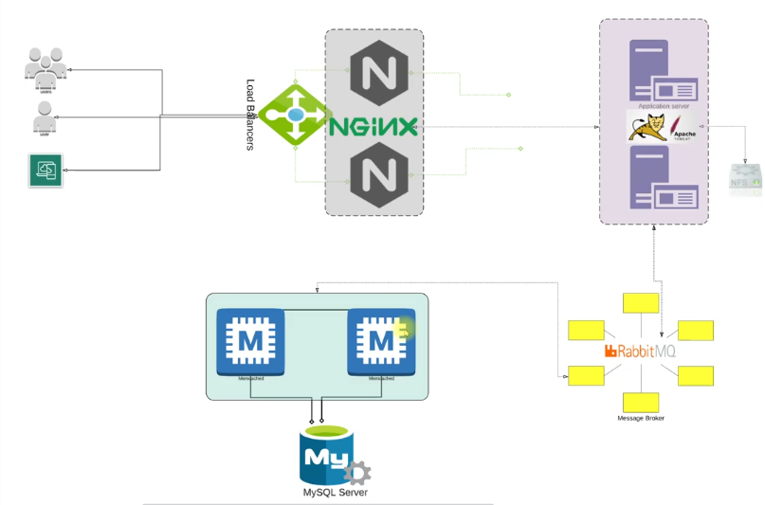

* Project Architecture (Automation Setup):

1. Oracle VM [VirtualBox]– It will be our Hypervisor
2. Terraform – It will be used for Automating
3. VS code – Command Line Interface (CLI) & Integrated Development Environment (IDE)

* Project Architecture (Services Design)